# CS 255 System Design Document Template

## UML Diagrams

### UML Use Case Diagram

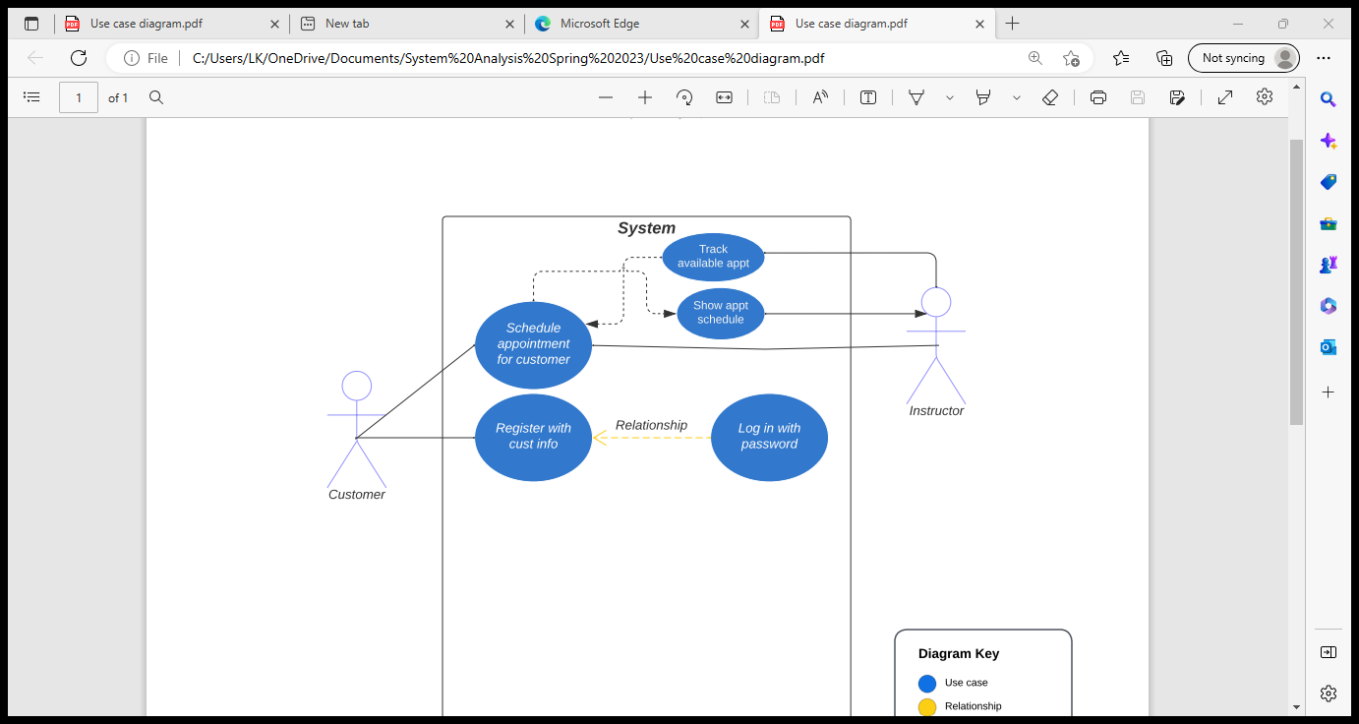

### UML Activity Diagrams

### UML Sequence Diagram

### UML Class Diagram

## Technical Requirements

*[Based on the diagrams you have created, describe the technical requirements of your system. These requirements should address the required hardware, software, tools, and infrastructure necessary for your system design.]*

For this project, there are several technical requirements such as:

1. The system should be accessible offline.
2. The system should be on the cloud to avoid maintenance of space.
3. The system should be accessible in any type of devices such as Windows, Macs, Linux, etc.